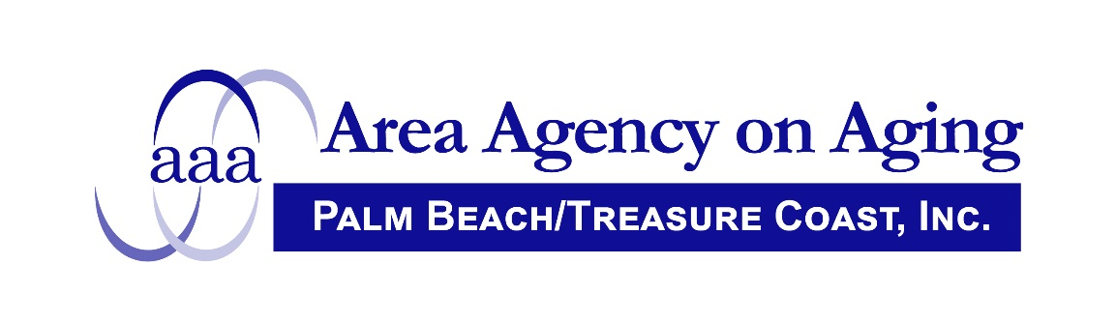

FOR IMMEDIATE RELEASE

Contact: Lee Hardy September 28, 2021
Area Agency on Aging
561/684-5885

AREA AGENCY ON AGING ANNOUNCES UPCOMING ADVISORY COUNCIL MEETING

The Area Agency on Aging of Palm Beach/Treasure Coast, Inc. is planning an Advisory Council meeting on Tuesday, October 5, 2021 to be held in person at 4400 N. Congress Avenue, West Palm Beach, Florida 33407 and via Zoom. The meeting is scheduled to begin at 8:30 a.m. Masks are required and social distancing is encouraged. Please call Lee Hardy, Area Agency on Aging, at 561 684-5885 for more information.

