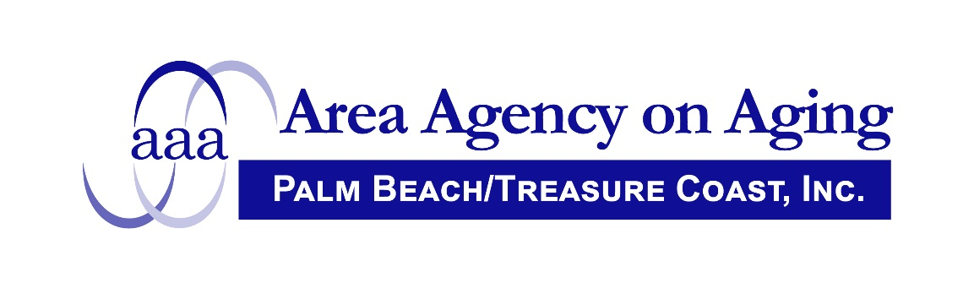

FOR IMMEDIATE RELEASE

Contact: Lee Hardy February 16, 2024
Area Agency on Aging
561/684-5885

THE AREA AGENCY ON AGING OF PALM BEACH/TREASURE COAST, INC. ANNOUNCES A PUBLIC MEETING TO WHICH ALL PERSONS ARE INVITED.

The Executive Committee of the Advisory Council will be meeting on Tuesday, May 14, 2024 to be held in person at 4400 N. Congress Avenue, West Palm Beach, Florida 33407 and via Zoom. The meeting is scheduled to begin at 8:30 a.m.

Please call Lee Hardy, Area Agency on Aging, at 561 684-5885 or email lhardy@aaapbtc.org for more information.

