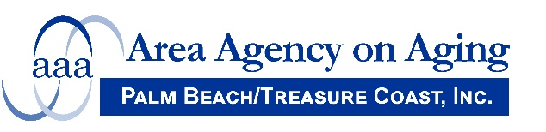
Area Agency on Aging of Palm Beach/Treasure Coast, Inc.
Public Hearing Regarding Direct Service Waivers
4400 North Congress Avenue, West Palm Beach, FL 33407
June 16, 2021 – 10:00 a.m.

AGENDA

- Welcome
- Discussion of Services Proposed to be provided as Direct Services
- Telephone Reassurance
- Education/Training Individual, Education/Training Group
- Evidence Based Workshops
- A Matter of Balance (MOB) and Un Asunto de Equilibrio
- Arthritis Foundation Tai Chi Program (Tai Chi for Arthritis)
- Chronic Disease Self-Management
- Diabetes Self-Management Program and Program de Manejo Personal de la Diabetes
- Enhance Fitness (EF)
- Powerful Tools for Caregivers
- Savvy Caregiver
- Tai Ji/Tai Chi Quan: Moving for Better Balance
- Tomando Control de su Salud
- Walk with Ease
- Public Comments – Scheduled Speakers
- Public Comments
- Adjournment

